About this Document
Applies to Chronolator Version | 3.4
Document version | 3.4.01
Purpose | Describes Word Options and Microsoft Office Group Policy Administrative Templates that affect the ability to run macros, and thus the ability to run Chronolator.

Microsoft Documentation
Microsoft describe the Group Policy Administrative Templates that pertain to Office 2016 in the article Plan security settings for VBA macros in Office 2016, available from here:
https://technet.microsoft.com/en-us/library/ee857085%28v=office.16%29.aspx or http://tinyurl.com/zn5bs9d.
Office 2010 and 2013 use the same definitions, apart from Block macros from running in Office files from the Internet, which is not directly relevant to Chronolator.

Recommendations
The Microsoft defaults allow a user to choose whether or not to run macros. If they choose to do so, macros will run successfully.
However, these defaults allow users to run any macro, with the risk that macro-borne viruses might infect their computer. Chronolator Version 3.4 macros are digitally signed by Berrick Computing Ltd, allowing you to set a more restrictive macro execution policy while still allowing Chronolator to run.
You can use Group Policy to enforce such a policy by setting VBA Macro Notification Settings to Disable all except digitally signed macros.
Group Policy allows you to set a more restrictive level for most users and just allow your Chronolator users to run macros.

A restrictive policy example
Chronolator has been successfully tested using a Local Group Policy. The GP Management Console was set up with these Snap-ins:
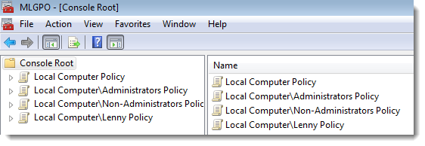
Very restrictive policies were set at the Local Computer Policy level, and relaxed for an individual user called Lenny. The Administrators and Non-Administrators policies were not changed. Similar options are possible depending on how and whether you want to set site-wide policies (for example, in a Non-Administrators policy rather than for the Local Computer).
Policy | Template Path | Setting
Automation Security | Local Computer Policy\User Configuration\Administrative Templates\Microsoft Office 2016\Security Settings | Enabled: Disable all macros by default
Disable VBA for Office applications | " | Enabled
Disable all Trust Bar notifications for security issues | " | Enabled
VBA Macro Notification Settings | Local Computer Policy\User Configuration\Administrative Templates\Microsoft Word 2016\Word Options\Security\Trust Center | Enabled: Disable all without notification
Automation Security | Local Computer\Lenny Policy\ User Configuration\Administrative Templates\Microsoft Office 2016\Security Settings | Enabled: Use application macro security level
Disable VBA for Office applications | " | Disabled
Disable all Trust Bar notifications for security issues | " | Disabled
VBA Macro Notification Settings | Local Computer\Lenny Policy\ User Configuration\Administrative Templates\Microsoft Word 2016\Word Options\Security\Trust Center | Enabled: Disable all except digitally signed macros

Berrick Computing as a Trusted Publisher
Berrick Computing does not need to be a Trusted Publisher, but being one makes things more convenient for users by removing the need for them to enable macros on a case-by-case basis.
Users can usually add Berrick Computing to their personal Trusted Publishers list by using standard Word features when opening a Chronolator Document. The Chronolator documentation tells them how to do this.
Some organisations might not want users to have this capability, and can use Group Policy to prevent it. If that applies to your organisation, and you want to add Berrick Computing to users' Trusted Publishers lists 'by hand', please contact julian.ladbury@berrick-computing.co.uk for a copy of the digital certificate .

Using a Trusted Location
Another way to allow an individual user to run macros is to give them a Trusted Location in Group Policy path Local Computer\username Policy\ User Configuration\Administrative Templates\Microsoft Word 2016\Word Options\Security\Trust Center\Trusted Locations.
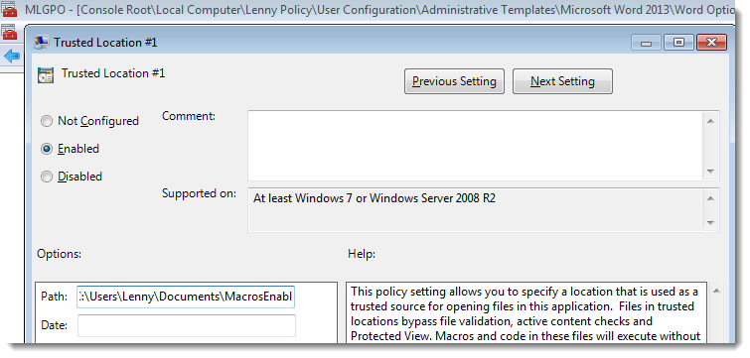
This option is less convenient than the one above in that it forces users to store data in a particular location. It is arguably less secure than setting Disable all except digitally signed macros in that if a malicious document were saved in that location it would be allowed to run macros without notification.
For Microsoft's advice on securing Trusted Locations, see https://technet.microsoft.com/en-us/library/cc179039(v=office.16).aspx or http://tinyurl.com/zvavbzk. The article is for Word 2016, but at the time of writing this document it has a link near the top to similar information for earlier versions:
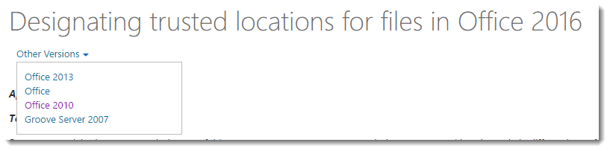

Settings that prevent Chronolator from running successully
- Not surprisingly, disabling VBA entirely by setting Disable VBA for Office applications will stop Chronolator running.
- Setting Automation security to Disable macros by default will allow macros to run at first (assuming the user or IT policy has allowed them to do so), but Chronolator will fail when one Chronolator Document attempts to open another one. This can happen when creating a new Internal Chronology or Composite Chronology from the Online Workbench, and when importing a chronology document into a Composite Chronology.
Note that the Automation security setting overrides any Trusted Locations that may be defined.

WARNING! See the Microsoft documentation mentioned above. If any of your users use Access, this setting will prevent them opening unsigned Access databases..

